BIOL 2510 Learning Objectives 5AB

Lecture 5A
- Describe the skin and hair changes associated with aging and define elastosis.
- Contrast the types of primary skin lesions. (Table provided.)

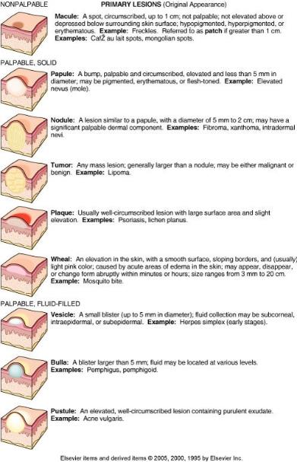

- Contrast the types of secondary skin lesions. (Table provided.)

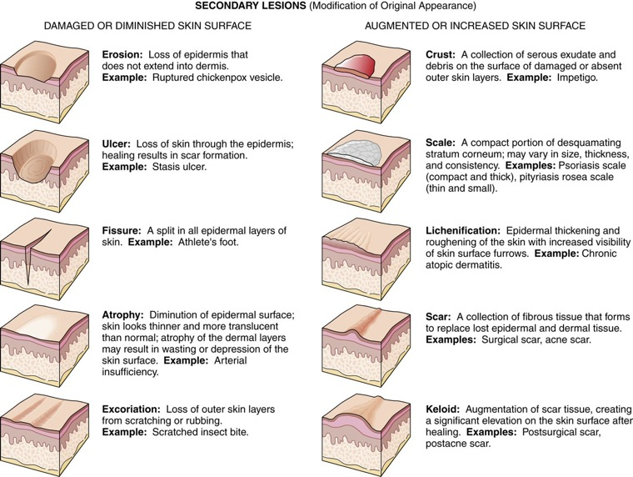
- List and define the terms used to describe the body location of skin lesions.
- List the names of the skin infections in this module and state whether each is causes by a virus, a bacterium or a fungus.
- Contrast viral infections that cause integumentary lesions with respect to lesion appearance/rash location and other manifestations: HPV, HSV types 1,2,3,6,7,8, rubella, rubeola and roseola. (Table provided)
Virus | Lesion Description | Rash Location | Other Manifestations
Human Papilloma Virus  (HPV) | Papules known as verrucae (warts) | Usually on hands or feet | Strains that cause warts are not the same as strains that cause cervical cancer.
Herpes Simplex Virus  (HSV) Type 1 and Type 2 | A progression occurs from vesicles to pustules to ulcers to crusts over a period of 10-14 days. | HSV type 1 infects above the waist (cold sores, for example)  HSV type infects the genital area and is sexually transmitted. | HSV persists in a dormant state in nerve ganglia and may cause recurrent infection at any time.
Herpes Simplex Virus  (HSV) Type 3 (Varicella-Zoster) | A progression occurs from vesicles to pustules to ulcers to crusts over a period of 10-14 days. | Chicken pox is a childhood form of the infection.  Shingles is a recurrence of infection. The rash occurs along the spinal nerve dermatomes causing pain along the dermatome. The lesion progression takes 2 to 3 weeks. | HSV persists in a dormant state in nerve ganglia and may cause recurrent infection at any time.  Post-herpetic neuralgia (persistence of dermatomal pain long after infection clears) is a possible complication of shingles.  Eye involvement may cause blindness.
Rubella Virus  (German measles) | Confluent pruritic maculopapular light red rash | The rash begins on the face and moves downward. The face clears as the rash moves inferiorly. | A TORCH infection capable of causing congenital defects (cataracts, deafness, heart anomalies) if it occurs in the mother early in pregnancy.  It may cause miscarriage.  May be accompanied by low-grade fever  Prevented by MMR vaccine
Rubeola Virus  (Red Measles aka Hard Measles) | Confluent flat (macular), red or brownish rash; usually not pruritic | The rash begins on the face and moves downward. The face clears as the rash moves inferiorly. | Accompanied by a high fever  Complications such as blindness, pneumonia or brain inflammation occur in 30%.  Prevented by MMR vaccine
Herpes Simplex Virus  Type 6 or Type 7  (Roseola Infantum aka Sixth Disease) | Spots or patches of maculopapular pink rash: not pruritic. | The rash begins on the trunk and moves to the face and arms. Legs may or may not be affected. | Occurs only in children, usually before age 2  Rash appears after a 3-day fever of greater than 103 degrees F.  Recurrence is rare.

- Contrast fungal infections that cause integumentary lesions with respect to specific causative organism and lesion appearance/rash locations: tinea capitis, tinea corpis, tinea barbae, tinea pedis, thrush, intertrigo, chronic mucocutaneous candidiasis and onychomycosis.
- Contrast bacterial infections that cause skin lesions with respect to specific causative organism, lesion appearance and locations and treatment: impetigo and acne vulgaris.
- Describe the difference between an open comedone and a closed comedone.
- Contrast the local and systemic treatments for acne vulgaris.
Lecture 5B
- Contrast non-infective skin disorders with respect to etiology and lesion appearance/locations: systemic lupus erythematosus, chronic discoid lupus erythematosus, seborrhea dermatitis, psoriasis and pemphigus. (Table provided)
Disorder | Etiology | Rash Description/Location
Systemic Lupus Erythematosus  (SLE) | Autoimmune response to the human nuclear material causing systemic disease  LE cell positive | Red, macular, scale-like, lesions  Occurs on the face in a butterfly (malar) pattern: cheek-nose-cheek), arms, fingers, legs; usually symmetric  No scarring or pigment loss
Chronic Discoid Lupus Erythematosus | Not associated with systemic symptoms  LE negative | Red, scale-like well-circumscribed plaques that are elevated at the edges  Occurs on the face (malar pattern) scalp, ears, arms, chest; may not be symmetric  Scarring, pigment loss and hair loss may occur.
Seborrhea dermatitis  Cradle cap in infants  Dandruff in adults | Unclear, but appears to be related to a heightened immune response to normal flora fungi of the genus Malassezia. | Reddened patches of greasy skin covered with flaky white or yellow scales or crusts occur where sebaceous glands are plentiful, usually on the head and face, but also
Psoriasis | Unclear, but appears to involve immune stimulation of epidermal keratinocytes. | Papules and patches with a silvery scale occur on knees, elbows, lower back, scalp, and nails.
Pemphigus | Autoantibodies are produced against keratinocytes and basement membrane components.  A combination of Type II (cytotoxic) and Type III (immune complex) hypersensitivity | Bullae erupt on skin and mucous membranes.  Without treatment (corticosteroids) infection and toxemia are dangerous complications.

- Identify non-infective skin disorders from photos.
- Contrast malignancies of the skin with respect to cell type of origin, lesion appearance and likelihood of metastasis: basal cell carcinoma, squamous cell carcinoma, malignant melanoma and Kaposi sarcoma.
- Describe the diagnostic importance of actinic keratosis.
- Identify skin cancer types from photos: basal cell carcinoma, squamous cell carcinoma, malignant melanoma.
- Define each letter in the ABCDE Rule for Malignant melanoma.
- Describe the etiology and progression of xeroderma pigmentosum (XP).
- If the mother and the father of an unborn child are both carriers for XP, what is the probability that the child will be affected by XP? (Punnett square required.)
- Contrast disorders of epidermal proliferation with respect to etiology, appearance and location: ichthyosis, corns and calluses.
- Contrast skin lesions caused by arthropod bites with respect to type of arthropod, bite lesion appearance/locations: mites, lice and bed bugs.
- Contrast tick-borne bacterial infections with respect to causative organism, lesion appearance/location and other manifestations: Lyme disease (all stages) and Rocky Mountain fever.
- Distinguish between the effects of UVA and UVB light on skin cells.
- List the sunscreen chemicals that protect against both UVA and UVB rays.
- Describe the etiology and prevention of decubitus ulcers.
- Describe the etiology and treatment of vitiligo.

